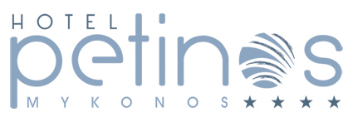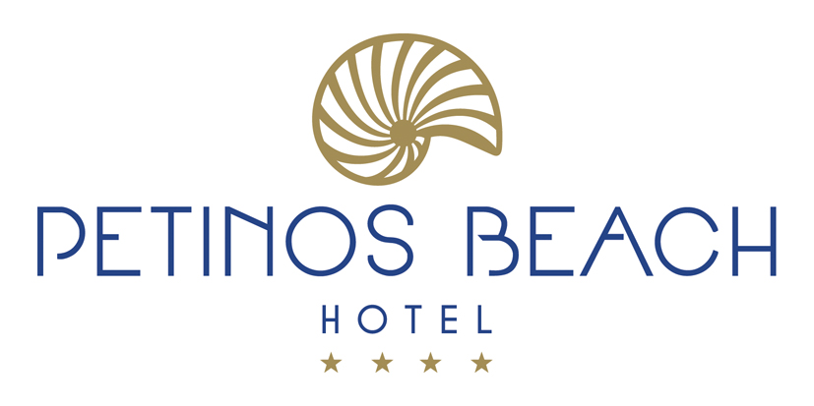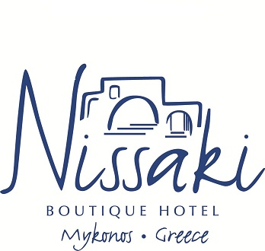

PETINOS HOTEL
PETINOS BEACH HOTEL & NISSAKI BOUTIQUE HOTEL
PLATY YIALOS BEACH, 84600 MYKONOS, P.O. BOX 116, GREECE
TEL.+30-22890 22913/24310 , FAX +30-22890-23680, e-mail: info@petinoshotels.gr
www.petinoshotels.gr

RESERVATION FORM

NAME(S):…………………………………………………………………………………………………………

………………………………………………………………………………………….………………………..

No. of Adults: ………………… No. of children:………..…..……..Ages:…………….…………………………

Source: Travel Agency:………………..……………………Other:……………………………………………..

ADDRESS:…………………………………..……………………………………………………………………

……..…………………………………………………………………………………………………………….

TEL #:…………………….…………………………CELLULAR #:………………….…………………………

Fax #:……………………………………….….E - mail:…………………………………….……………….

Arrival date: …………………… Departure date:…………….………… No. of nights: ………………

No. ………………..Room types: ……………………..………………………………………………………

Rate on bed and breakfast: ………………………..euro per room per night including all taxes

Credit card: AMEX / VISA / MASTER Credit card holder:…………..……………………….……………..

Credit card No: ……………………………………………………………………Exp. date:……………….

Transfer upon arrival / departure from / to airport- port : YES / NO

Arrival time: ………………Flight #:……………Name of boat……………………………………………...

Departure date & time:………………………………Flight #:…………Name of boat……………..………..

Remarks:…………………………………………………………………………………………………………

Cancellation policy:

No charges for cancellation up to 7 days prior to arrival
Cancellation within the penalty period: 30% of the total stay charges
Non show or earlier than scheduled departure: 100% charges of the entire stay

FULL NAME:……………………………………………………………………………………………………

SIGNATURE: ……………………………………………………………………………..…………………..

